**Coding Standards – View Model**

1. 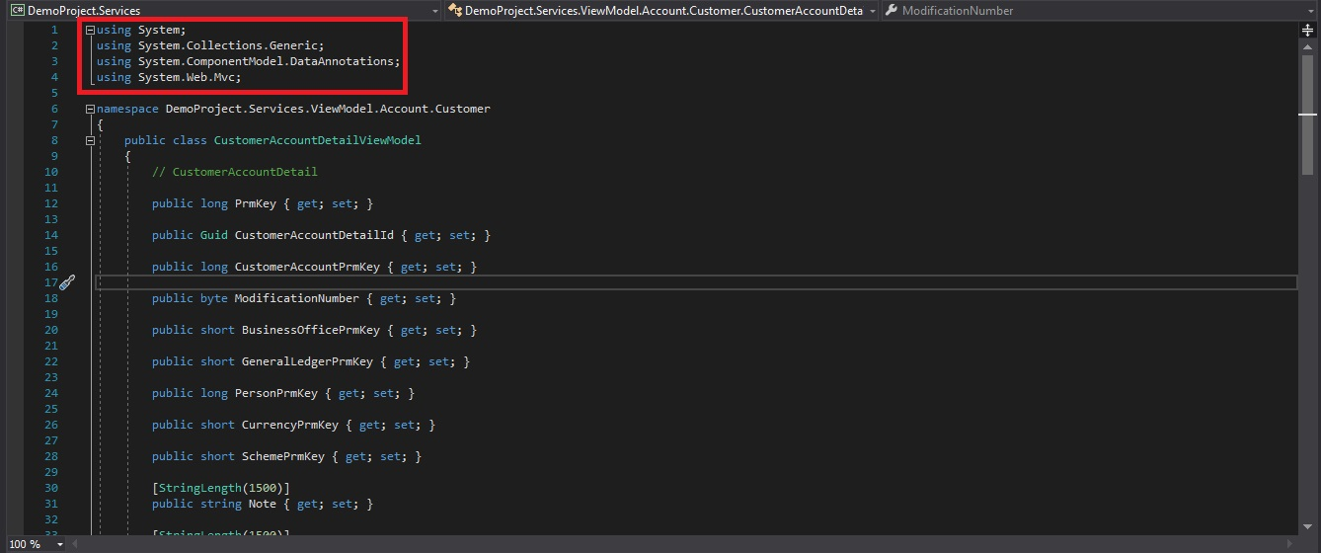Using Statements Must Be Placed Above Namespace.
2. 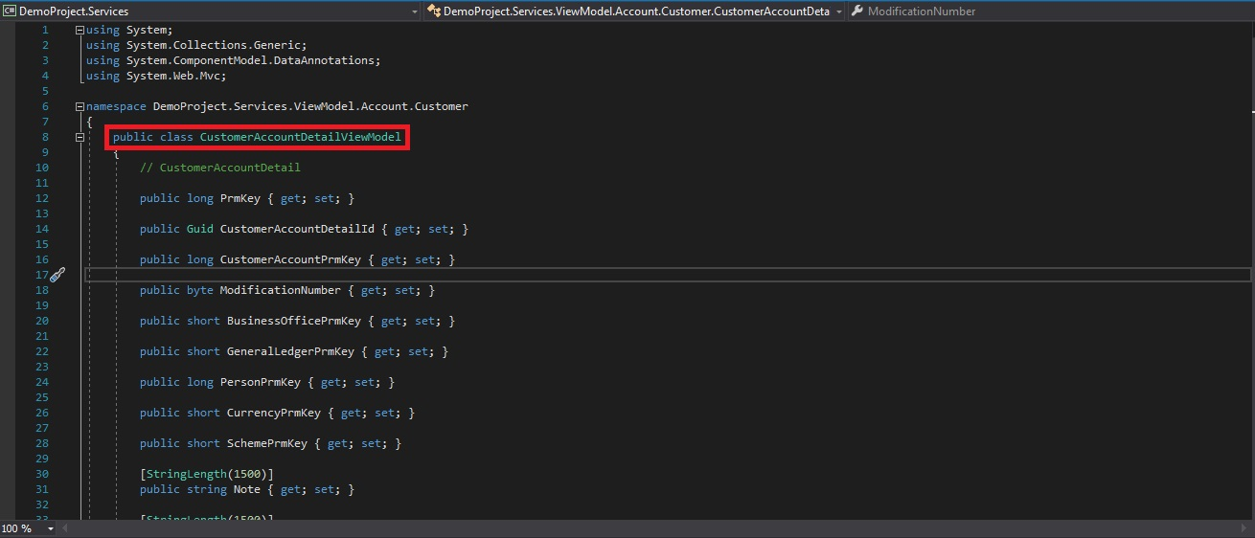View Model Class Must Be A Public Class.
3. View Model Class Name Must Be Same As Entities Class With Suffix ViewModel.

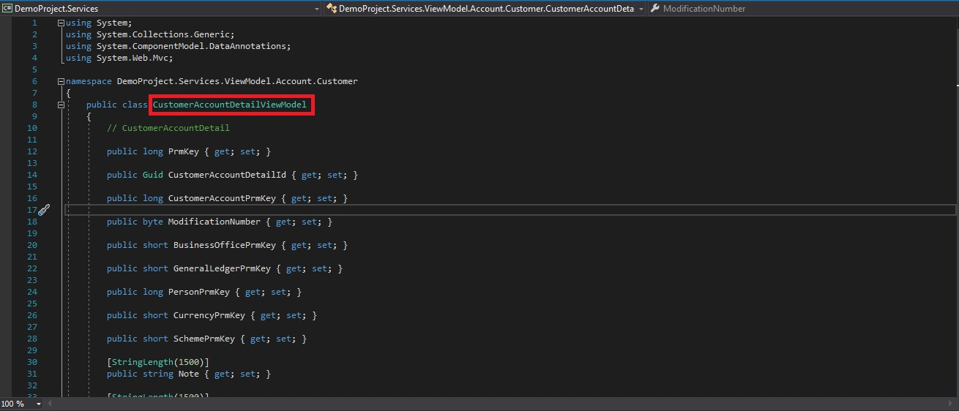

1. 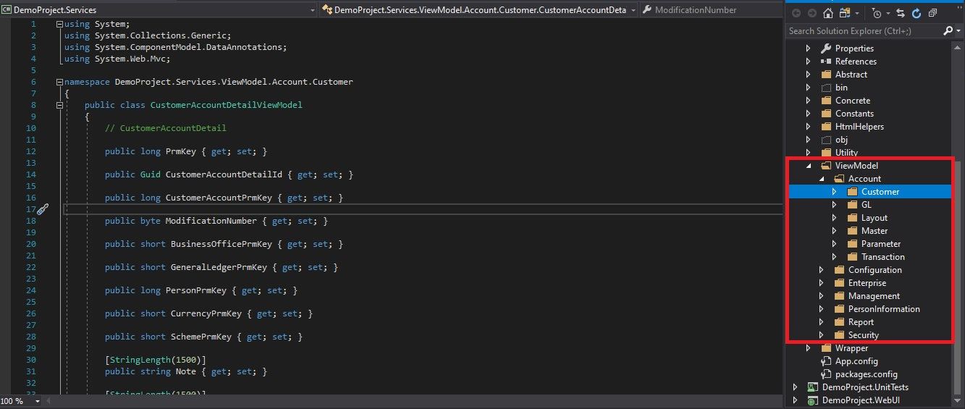Folder Structure Must Be Same As Entity Except Exceptional Cases.
2. Include View Model Within View Model Except Its Property.

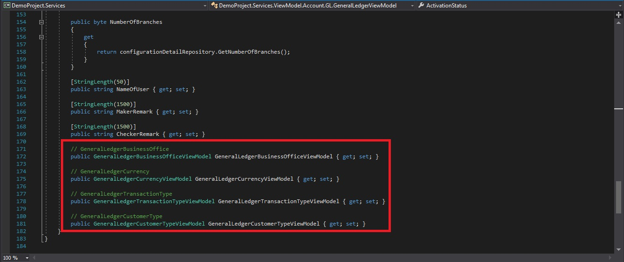

1. Cannot Decorate Class Variables With **[Required], [Key]** Data Annotations.
2. 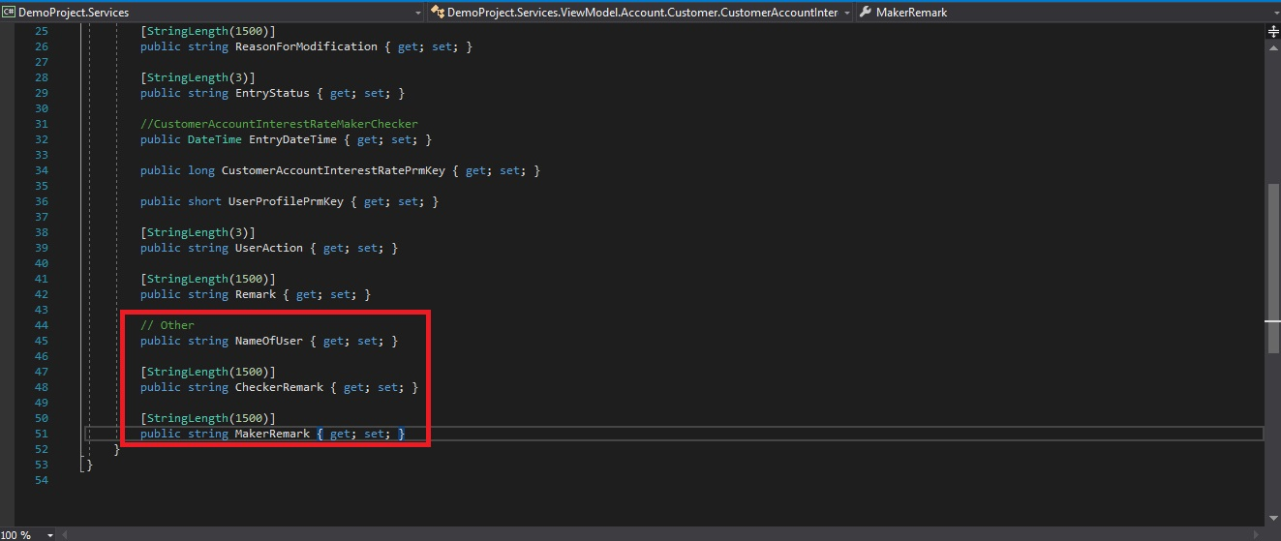Always Define **NameOfUser**, **CheckerRemark** And **MakerRemark** In View Model Wherever Required Under Other Section.
3. Apply Data Annotations For String Type Variables Only, With **[Stringlength()]** Attribute.

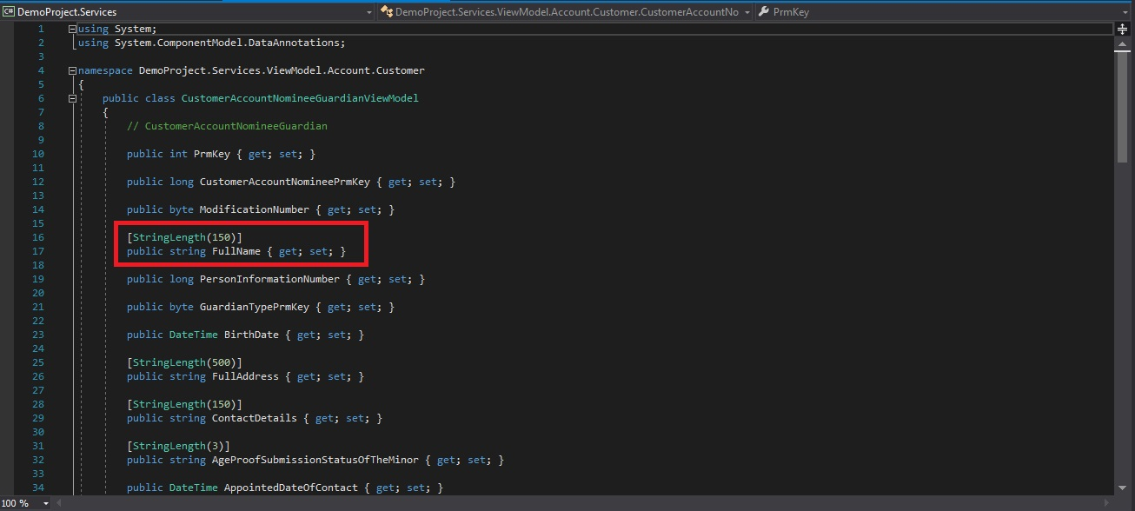

1. 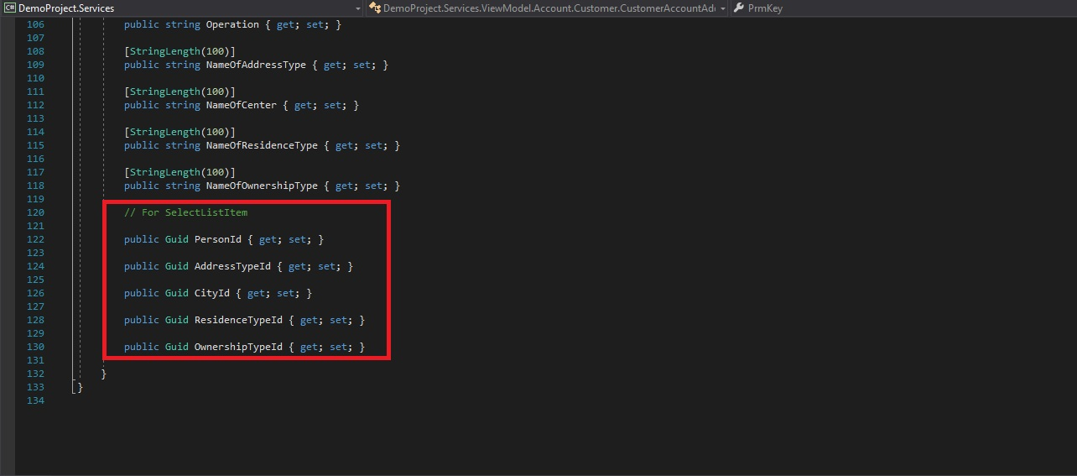Always Add Id Fields For Dropdowns If Exists.
2. 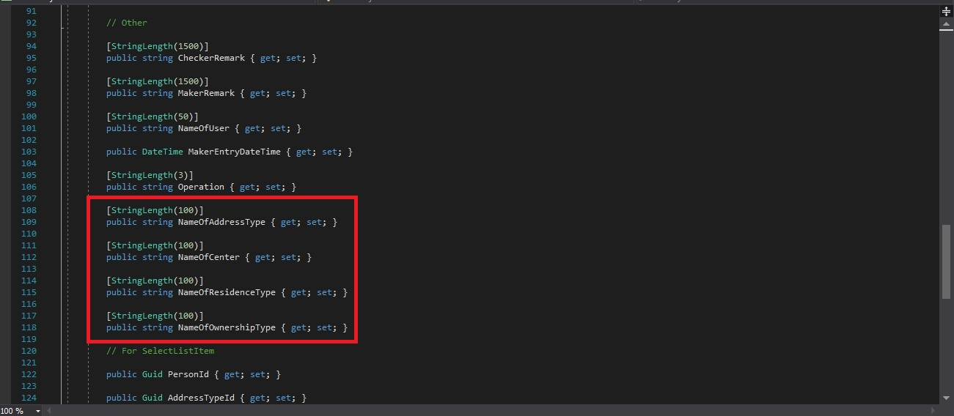 Always Add Text Of Id’s For Data Table And Dropdown If Exists